###### Shell Programming: Shell Scripts

Subject:- Unix Operating System System Lab Class :- TYIT

**Name: - SHRENIK JADHAV**

**OM GHARGE**

**PRN: -2020BTEIT00011,2020BTEIT00041**

**Assignment No** - **5b**

**Title-**Write a program to implement a digital clock using shell script.

**Objectives –**

1. To learn shell programming and use it for write effective programs.

**Theory-**

A shell in a Linux operating system takes input from you in the form of commands, processes it, and then gives an output. It is the interface through which a user works on the programs, commands, and scripts. A shell is accessed by a terminal which runs it.

When you run the terminal, the Shell issues a command prompt (usually $), where you can type your input, which is then executed when you hit the Enter key. The output or the result is thereafter displayed on the terminal.

The Shell wraps around the delicate interior of an Operating system protecting it from accidental damage. Hence the name Shell.

**Flowchart-**

Enter into the while loop

date+’%a%b

%e%Y%n%l

%M%p’

check for this

Fals e

Tru e

end

Use awk command to prit the date

**Program-**

**while true; do**

**clear # Clear the screen**

echo "Digital Clock"

echo "----------------"

echo $(date +"%T") # Display the current time in HH:MM:SS format

sleep 1 # Pause for 1 second

done

**run--**

**Open a text editor and copy the Bash script code into a new file.**

* Save the file with a .sh extension, for example, digital_clock.sh.
* Open a terminal on your Ubuntu system.
* Navigate to the directory where you saved the Bash script using the cd command. For example, if you saved the script in your home directory, you can use the following command:

bash

* cd ~
* Make the script file executable by running the following command:

bash

* chmod +x digital_clock.sh

This command grants execute permissions to the script file.

* Run the Bash script by entering the following command:

bash

* ./digital_clock.sh

This command executes the script and starts the digital clock.

* The script will continuously clear the screen, display the text "Digital Clock" and a horizontal line, then display the current time in the format HH:MM:SS.
* The script will pause for 1 second using the sleep command, and then repeat the process to update the displayed time every second.

**Output-**

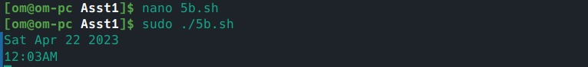

**Conclusion:**

System date is retrieve using shell programming

**References:**

https://[www.tutorialspoint.com/unix/unix-what-is-shell.htm/](http://www.tutorialspoint.com/unix/unix-what-is-shell.htm/)